**ASSIGNMENT 2**

**Part A**

What will the following commands do?

• echo "Hello, World!"

Print Hello, World! on terminal

• name="Productive"

Echo $name

It print Productive on terminal

• touch file.txt

Create empty file

• ls -a

Show hidden content or hidden file

• rm file.txt

Remove the file and recurcive directory

• cp file1.txt file2.txt

Copy the file1.txt content to file2.txt

• mv file.txt /path/to/directory/

Move file.txt to another directory

• chmod 755 script.sh

4 read

2 write

1 execute

7 Gives read , write ,execute permission to user

5 gives read , execute permission to group

5 gives read , execute permission to other

• grep "pattern" file.txt

Search the word pattern into file.txt

• kill PID

Terminate the process by using process ID

The **kill** command kills a single process at a time with the given process ID. It sends a **SIGTERM** signal instructing a process to stop. It waits for the program to run its shutdown routine.

The **-signal** option can be used to specify a signal other than **SIGTERM**.

Kill -l shows all signal and its signal number

• mkdir mydir && cd mydir && touch file.txt && echo "Hello, World!" > file.txt && cat file.txt

First by using mkdir it will create directory of name mkdir

Then by using cd mydir it change root directory to mydir

By using touch file.txt it Create empty file with name file.txt

By using echo it Print Hello, World! Into the file

By using cat show the content of file

• ls -l | grep ".txt"

It shows all files with .txt extension in current directory

• cat file1.txt file2.txt | sort | uniq

Cat file1.txt file2.txt concatenate file and sort them by alphabetically if there is duplicate value present then it shows only one unique value

• ls -l | grep "^d"

It shows all subdirectory in current directory

• grep -r "pattern" /path/to/directory/

search pattern text recursively through all directories and subdirectories under the specified path.

• cat file1.txt file2.txt | sort | uniq –d

Cat concatenate content of file1 and file2 and sort them by alphabet and -d option tells uniq to display only lines that are repeated, meaning it will only show lines that are duplicates.

• chmod 644 file.txt

**6 (read and write)**: permission to owner of the file can read and write the file.

**4 (read-only)**: permission to associated with the file can only read the file.

**4 (read-only)**: permission to Others (everyone else) can only read the file.

• cp -r source_directory destination_directory

Copy all the files and directory from source directory to destination directory

• find /path/to/search -name "*.txt"

Find files with .txt extension

• chmod u+x file.txt

Give permission to user to execute file.txt

• echo $PATH Part B

**echo**: A command that prints text or variables to the terminal.

**$PATH**: Refers to the PATH environment variable. The $ symbol is used to access the value of the variable.

It displays the current value of the $PATH variable. The $PATH variable is an environment variable that lists directories where the system looks for executable files. It's important for command-line use because it allows users to run programs from any directory without typing the full path.

**Part B**

**Identify True or False:**

1. ls is used to list files and directories in a directory.

TRUE

1. mv is used to move files and directories.

TRUE

1. cd is used to copy files and directories.

FALSE

1. pwd stands for "print working directory" and displays the current directory.

FALSE

1. grep is used to search for patterns in files.

TRUE

1. chmod 755 file.txt gives read, write, and execute permissions to the owner, and read and execute permissions to group and others.

TRUE

1. mkdir -p directory1/directory2 creates nested directories, creating directory2 inside directory1 if directory1 does not exist.

TRUE

1. rm -rf file.txt deletes a file forcefully without confirmation.

TRUE

**Identify the Incorrect Commands:**

1. chmodx is used to change file permissions. Incorrect

Correct :Chmod u+x file.txt

2. cpy is used to copy files and directories. Incorrect

Correct :cp

3. mkfile is used to create a new file. Incorrect

Correct :Touch file.txt or nano file.txt

4. catx is used to concatenate files. Incorrect

Correct : cat file1.txt file2.txt

5. rn is used to rename files. Incorrect

Correct : mv old_name.txt new_name.txt

**Part C**

Question 1: Write a shell script that prints "Hello, World!" to the terminal.





Question 2: Declare a variable named "name" and assign the value "CDAC Mumbai" to it. Print the value of the variable.



Question 3: Write a shell script that takes a number as input from the user and prints it.





Question 4: Write a shell script that performs addition of two numbers (e.g., 5 and 3) and prints the result.

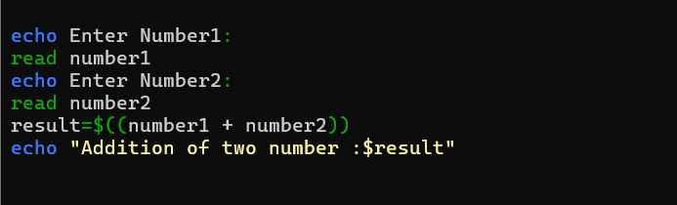

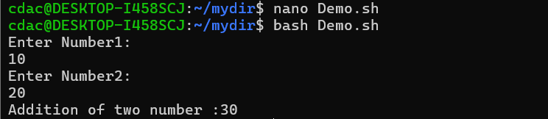

Question 5: Write a shell script that takes a number as input and prints "Even" if it is even, otherwise prints "Odd".

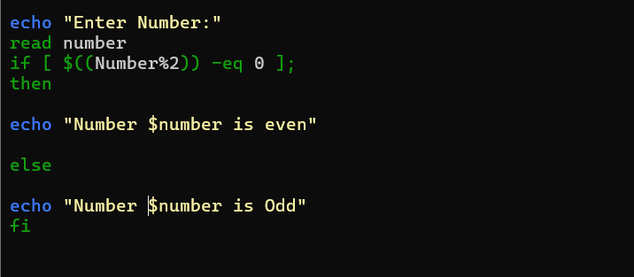

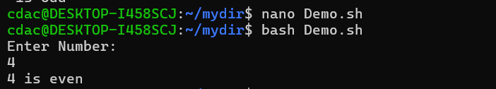

Question 6: Write a shell script that uses a for loop to print numbers from 1 to 5.

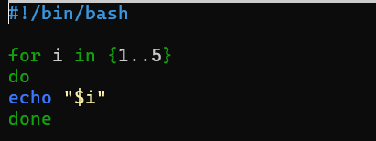

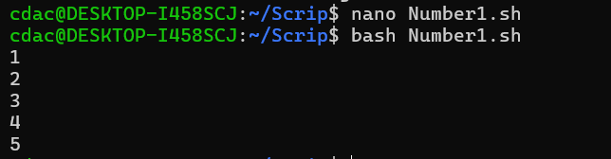

Question 7: Write a shell script that uses a while loop to print numbers from 1 to 5.

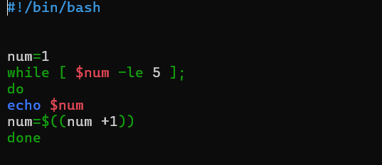

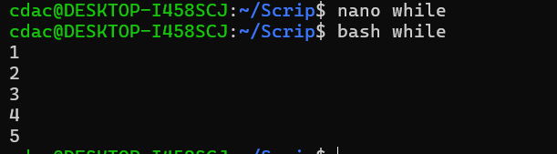

Question 8: Write a shell script that checks if a file named "file.txt" exists in the current directory. If it does, print "File exists", otherwise, print "File does not exist".

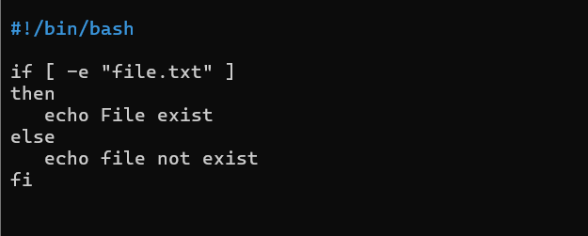

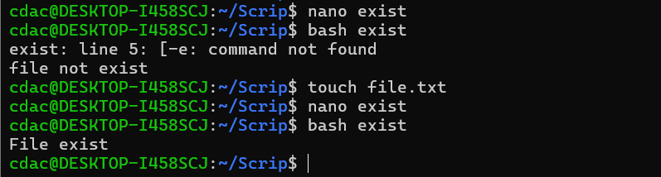

Question 9: Write a shell script that uses the if statement to check if a number is greater than 10 and prints a message accordingly.

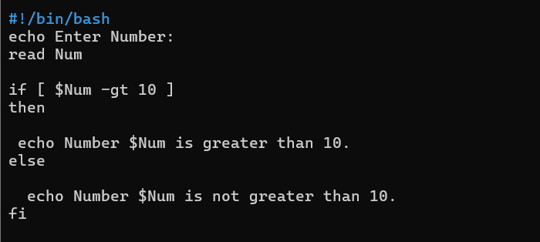

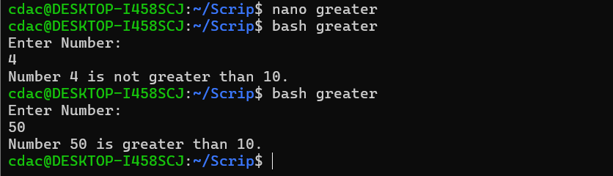

Question 10: Write a shell script that uses nested for loops to print a multiplication table for numbers from 1 to 5. The output should be formatted nicely, with each row representing a number and each column representing the multiplication result for that number.

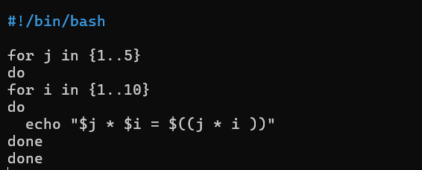

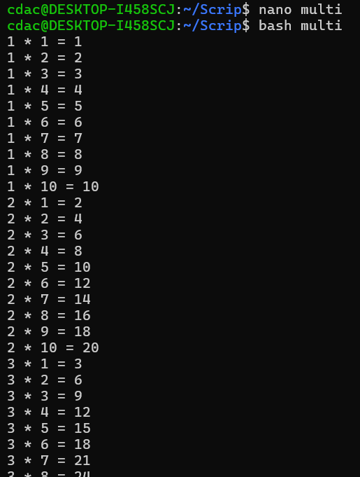

Question 11: Write a shell script that uses a while loop to read numbers from the user until the user enters a negative number. For each positive number entered, print its square. Use the break statement to exit the loop when a negative number is entered.

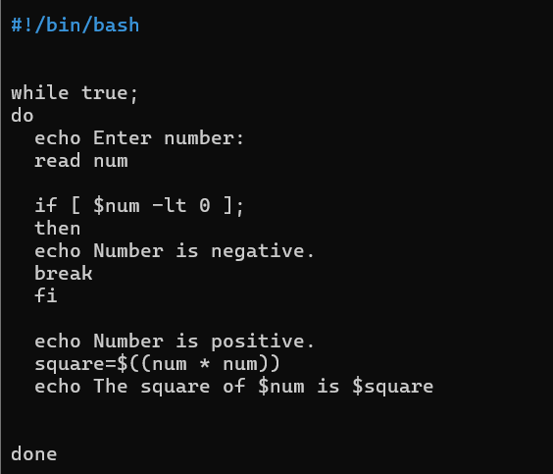

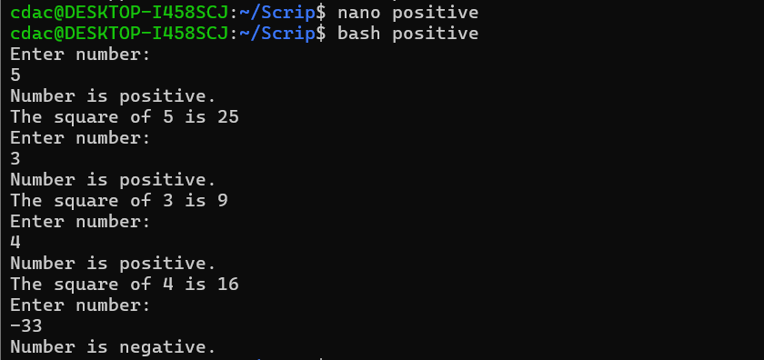

**Part D**

**Interview Questions on another file.**

**Part E**

1. Consider the following processes with arrival times and burst times: Calculate the average waiting time using First-Come, First-Served (FCFS) scheduling.

2. Consider the following processes with arrival times and burst timesCalculate the average turnaround time using Shortest Job First (SJF) scheduling.

3. Consider the following processes with arrival times, burst times, and priorities (lower number indicates higher priorityCalculate the average waiting time using Priority Scheduling. 4. Consider the following processes with arrival times and burst times, and the time quantum for Round Robin scheduling is 2 units: Calculate the average turnaround time using Round Robin scheduling.

5. Consider a program that uses the fork() system call to create a child process. Initially, the parent process has a variable x with a value of 5. After forking, both the parent and child processes increment the value of x by 1. What will be the final values of x in the parent and child processes after the fork() call?

